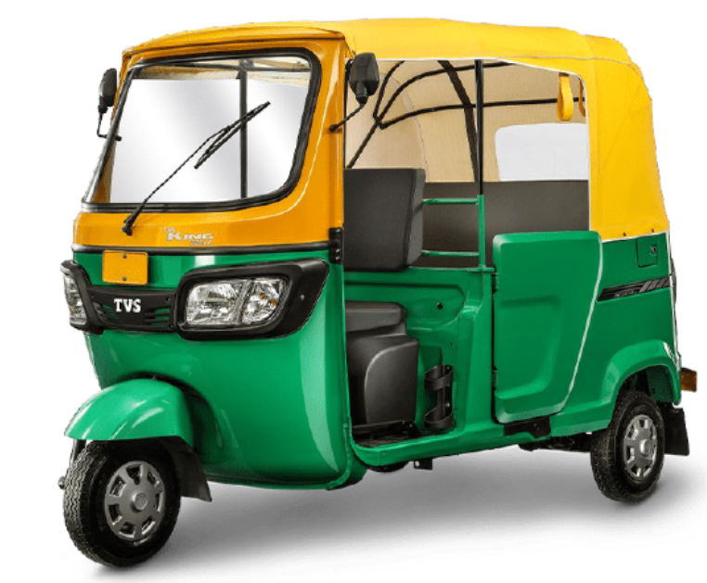

BAJAJ 3WHEELER SPARES

CLUTCH PLATES WHEEL CYL KIT BS-6, MASTER CYL BOTTLE WHEEL COIL RUBBER
ENGINE HEADCOVER DOOR NUT 2 STROKE RE MAGNET FAN
2 STROKE FAN COVER RE JUMPER SPRING PAD PRESS 2T OIL TANK CAP MC BOTTLE CAP
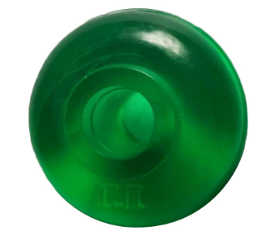
MC BOTTLE COMPACT CAP FRONT GREEN SHOCKER RUBBER REAR GREEN SHOCKER RUBBER
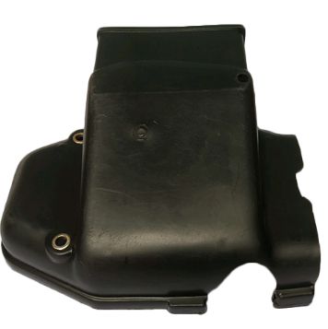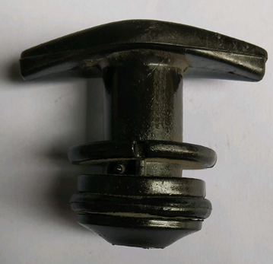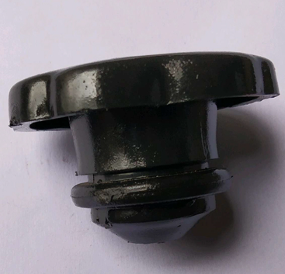
CLUTCH COVERS 4 STROKE PT CAP PETROL TANK CAP

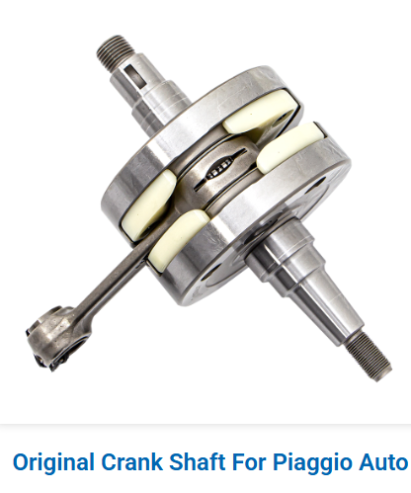

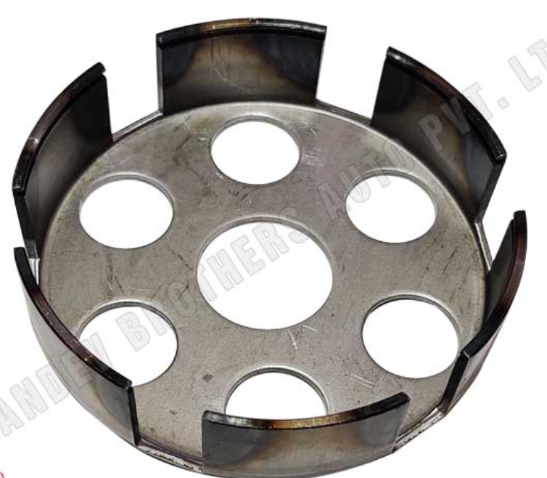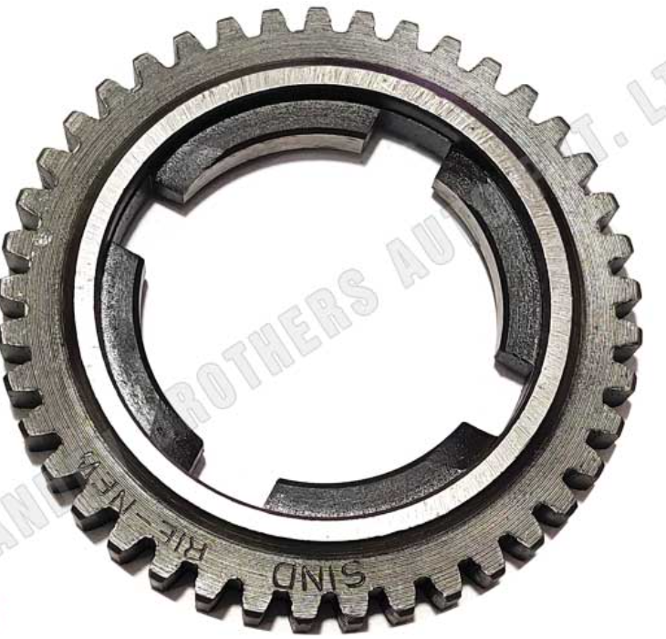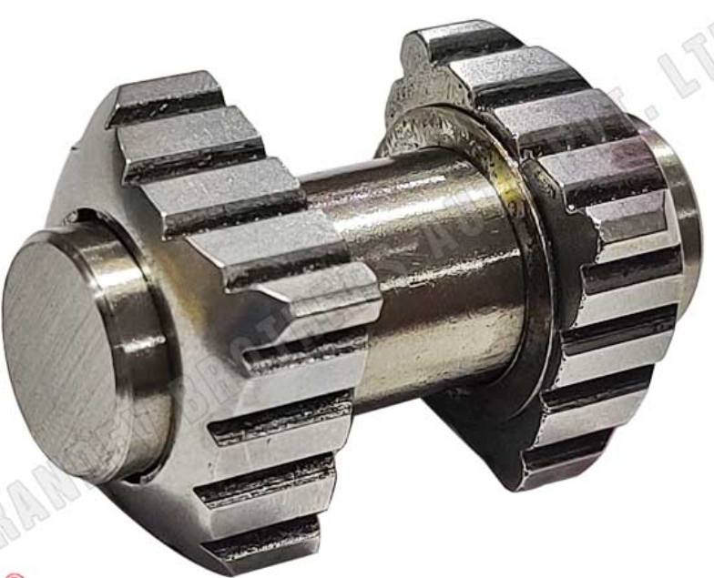
CLUTCH BELL TOP GEAR SLIDER BLOCK

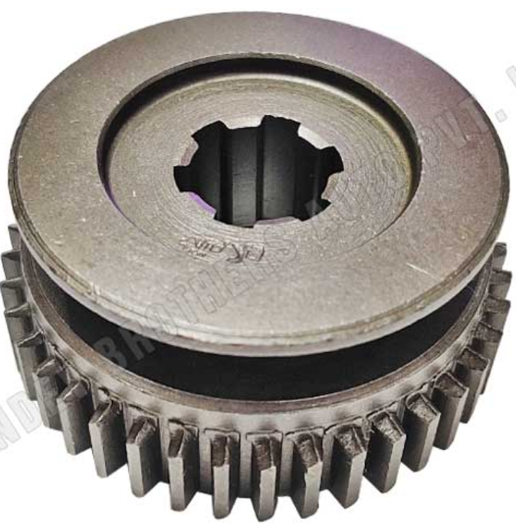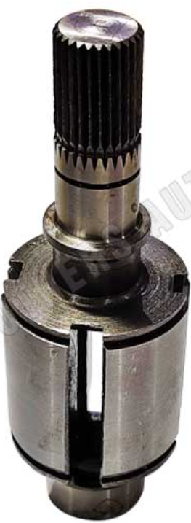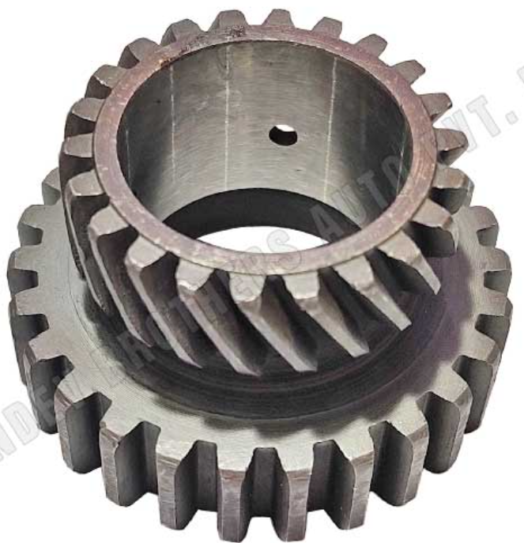
REVERSE GEAR MAIN SHAFT MAIN GEAR

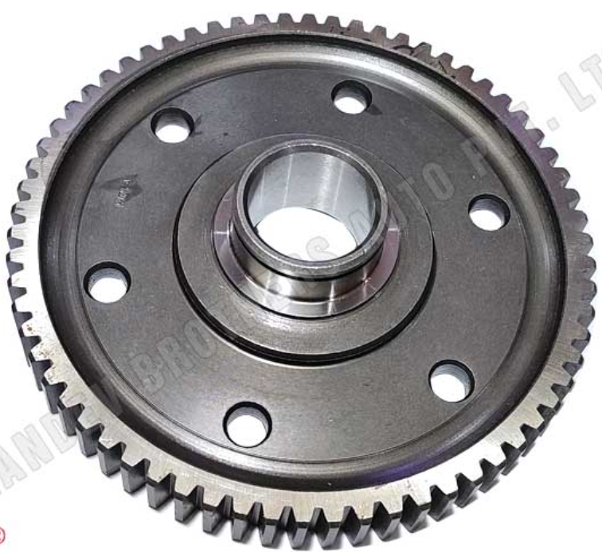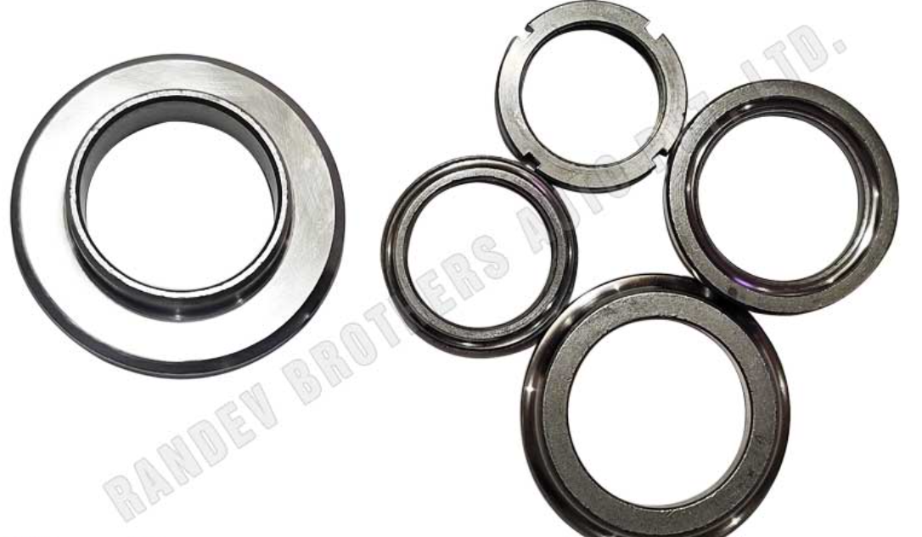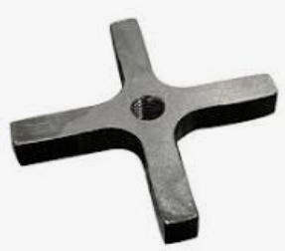
DIFFERENTIAL GEAR CUP CONE SET GEAR CROSS

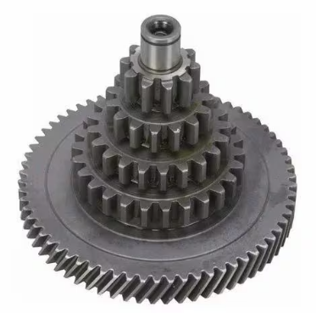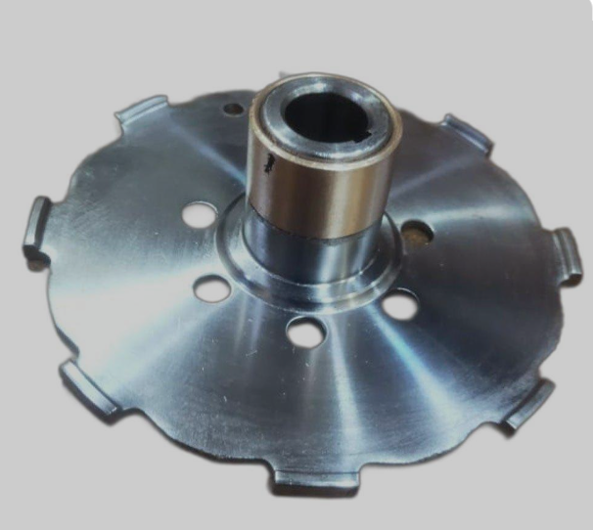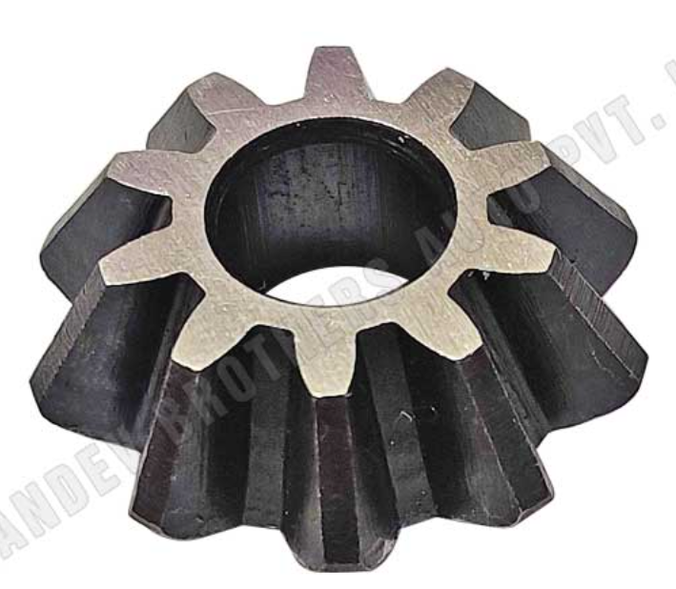
CLUSTER GEAR BUSH PLATE BEVEL GEAR

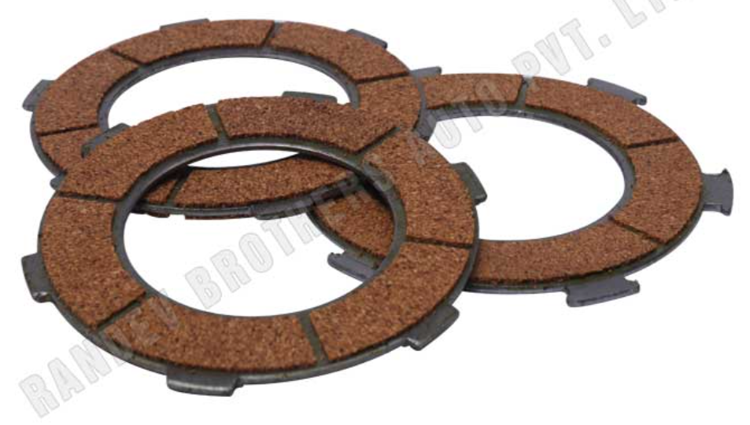
CLUTCH PLATES

